SOAP in POSTMAN

**Development Environment**

* Postman
* Endpoint url

Creating a collection

* Open Postman
* Click on **New**
* Select Collection

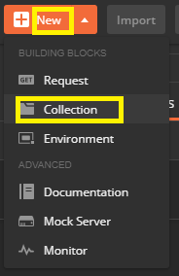

Creating a New Request

* Go to New
* Select Request

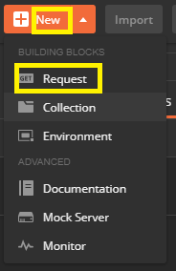

Providing the Request data in body

* Go to Request body
* Click on raw
* Select **Xml(text/xml)**

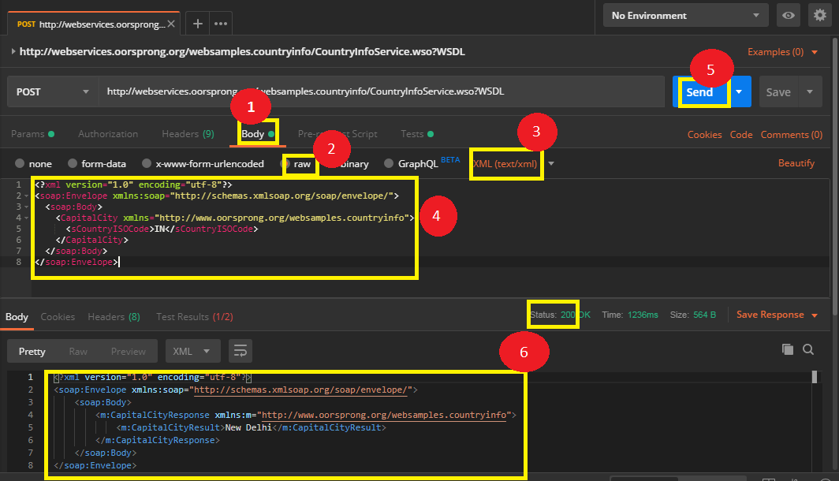

Validating the request

* Go to **Test**
* Pass the snippet which shows status code as 200

